Bazaar Ceramics Project

Database Design

And

Architecture



Institute of Technology Australia

*Author:* Alessandro Ferro

|  |  |
| --- | --- |
| **Version History** | |
| **Version #** | **Date** | | **Revised By** | **Reason for change** |
| **1.0** | **12/03/2021** | | **Alessandro Ferro** | **NA** |
|  |  | |  |  |
|  |  | |  |  |
|  |  | |  |  |

# Forms used in the organization

|  |  |
| --- | --- |
| **Telephone order form for account customers** | **Telephone order form for non-account customers** |
|  |  |

|  |
| --- |
| Product |
|  |

# Information required

|  |  |
| --- | --- |
| Users | Products |
| * Account number * First name * Last name * Role * Email * Password * Address * Date created | * Product name * Product image * Product description * Size * Price * Glaze type * Category * Date produced |
| Orders | Messages |
| * Total price * Customer * Date of order | * Name * Subject * Email * Body |
| Order_Details |  |
| * ItemId * Quantity per item * Unit price * Discount |  |

# Logical Model

Design realized using lucidchart.com

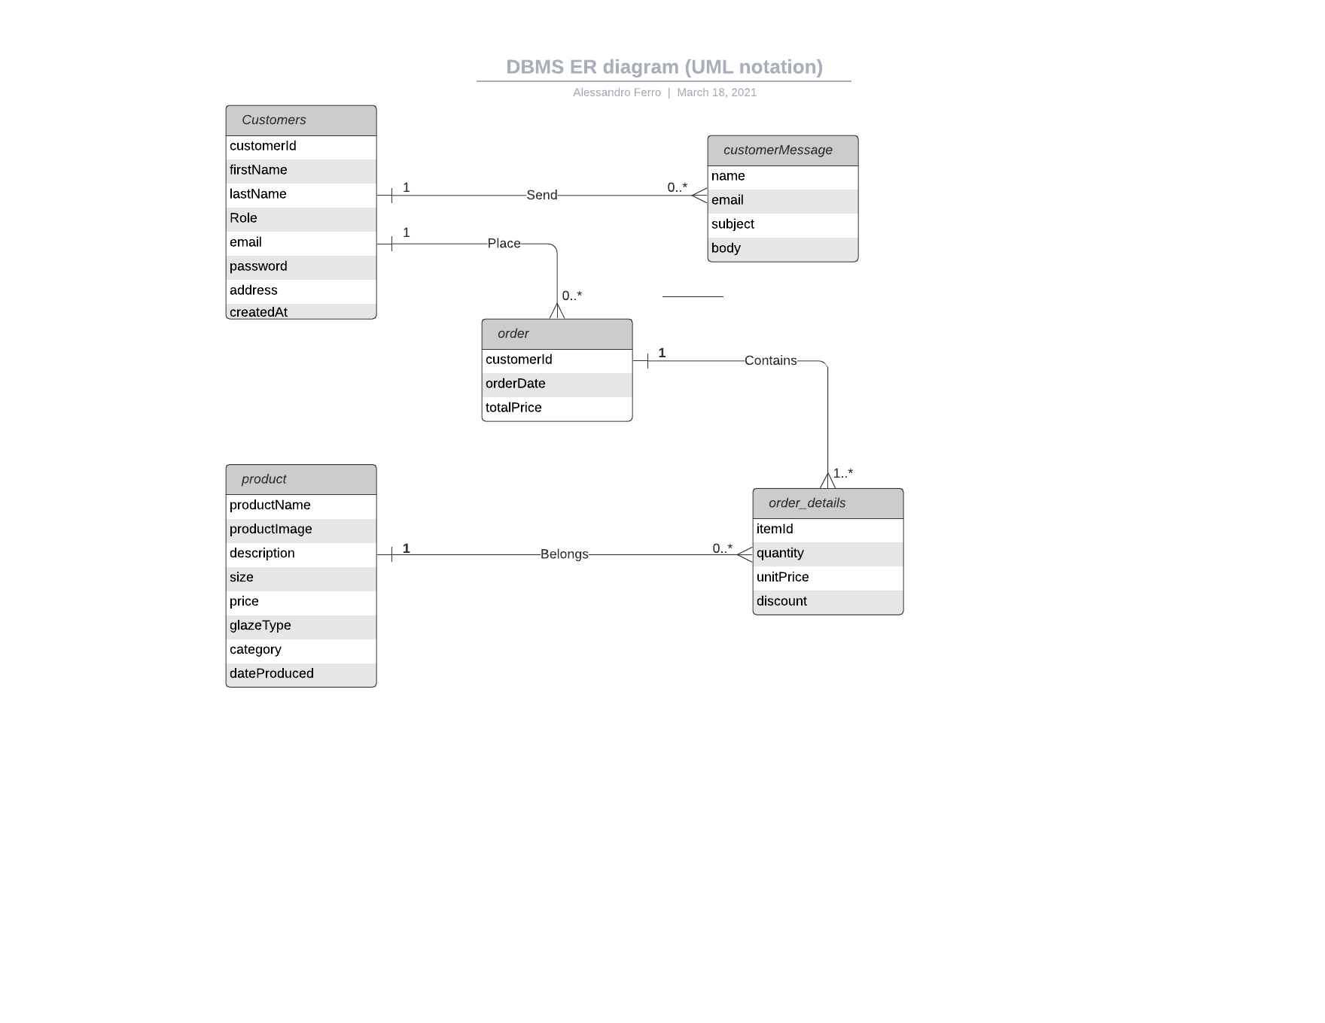

# Normalization

# First Normal Form

users

*userID* (PK), firstName, lastName, role, email, password, **addressId** (FK), dateCreated

address

*addressId (PK),* address1, region, postalCode, country

products

*productId* (PK), productName, productImage, productDescription, size, price, glazeType, category, dateProduced

orders

*orderId* (PK), totalPrice, **customerId** (FK), orderDate

orders_details

*orderDetailsId* (PK), **productId** (FK), quantity, unitPrice, discount

messages

*messageId* (PK), name, subject, email, body

# Second Normal Form

Each non-key value is already fully dependent on the entire primary key of their table, therefore the design already complies with the rules of the second normal form.

# 4.3 Third Normal Form

users

*userID* (PK), firstName, lastName, role, email, password, dateCreated

address

*addressId (PK),* **userID** (FK),address1, city, region, postalCode, country

products

*productId* (PK), productName, categoryId, productImage, productDescription, size, price, glazeType, dateProduced

categories

*categoryId* (PK), description

orders

*orderId* (PK), totalPrice, **customerId** (FK), orderDate

orders_details

*order_detailsId* (PK), **orderId** (FK), **productId** (FK), quantity, unitPrice, discount

orders

*cartId*(PK), **customerId**(FK), createdAt

item_cart

*item_cartId* (PK), **productId** (FK), **userId** (FK), unitPrice

email

*emailId* (PK), name, subject, email, body, receiver, dateSent

# Physical Design

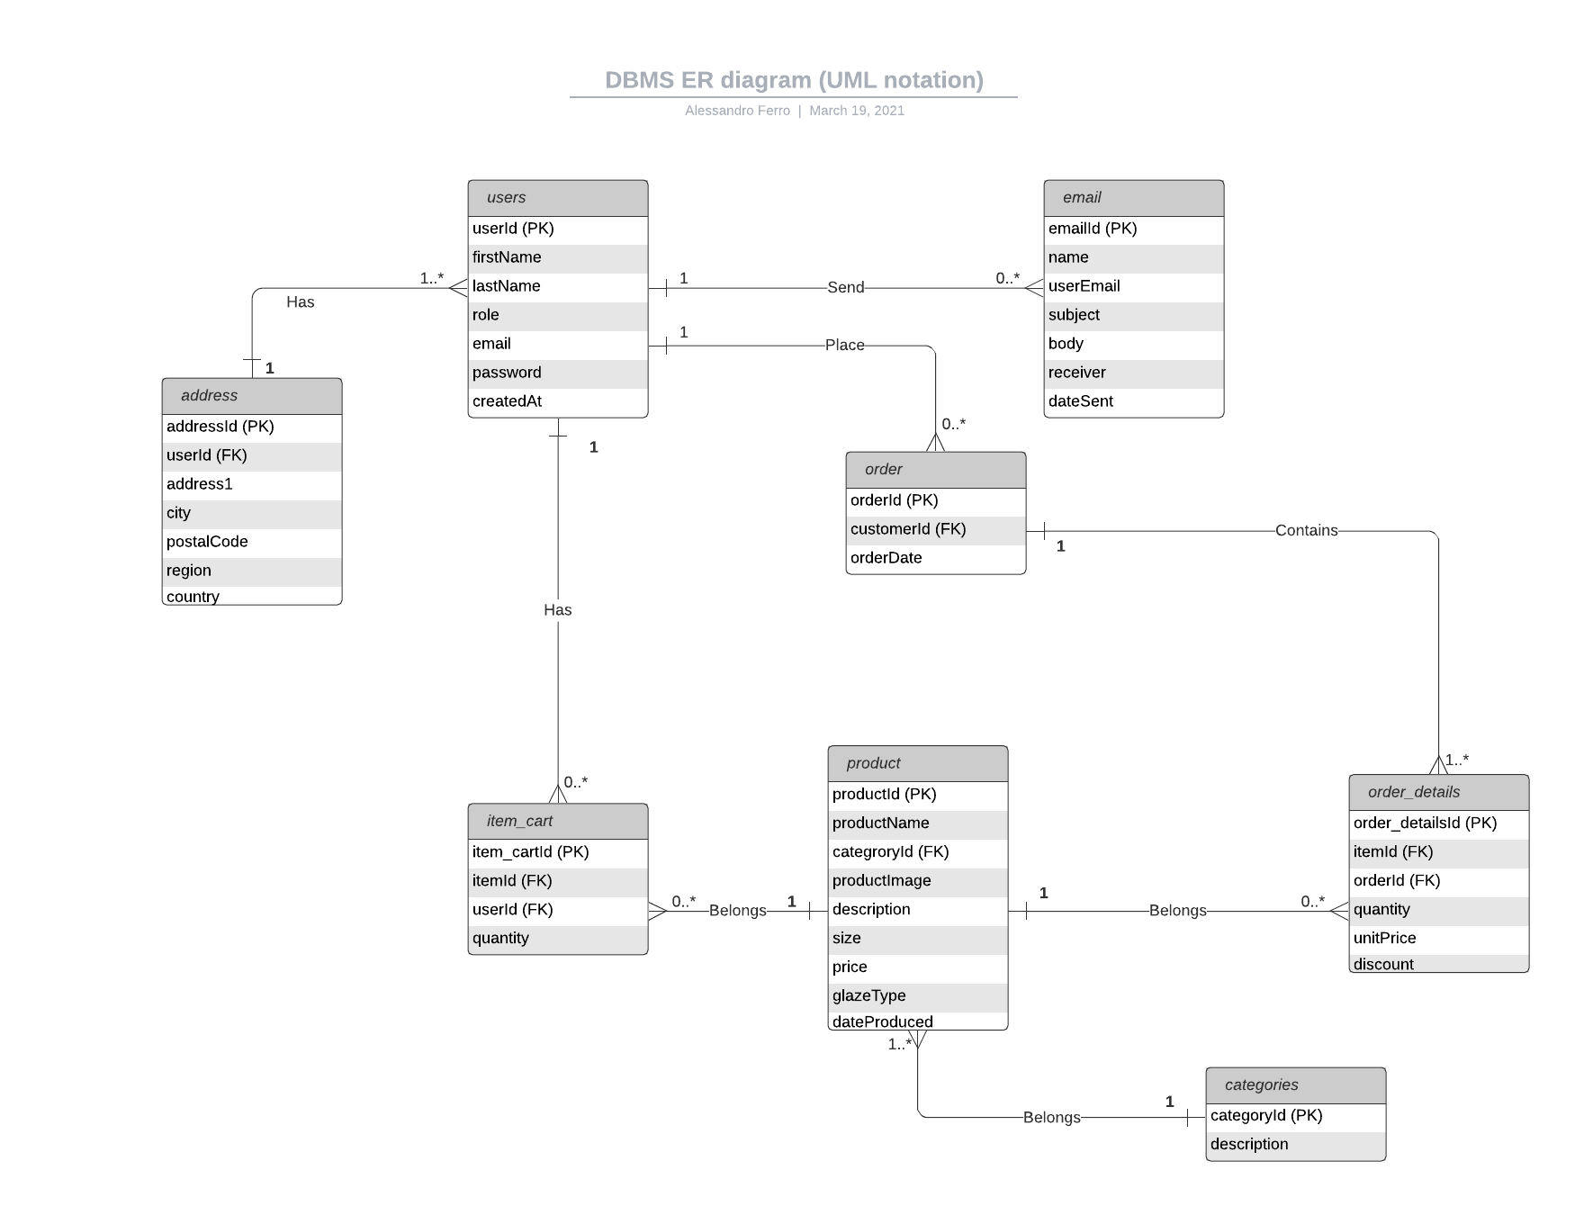

# Tables and Data

|  |  |  |
| --- | --- | --- |
| **address** | | |
| **Attribute** | **Data type** | **Description** |
| addressId (PK) | VARCHAR(255) | Unique identifier of each address row |
| userId (FK) | VARCHAR(255) | Unique identifier of each user row |
| addressLine | VARCHAR(255) | Street, number and unit or P.O. Box |
| City | VARCHAR(255) | City or town of the user address |
| postalCode | VARCHAR(255) | Postal code of the city or town of the user address |
| Region | VARCHAR(255) | Region or State of the user address |
| Country | VARCHAR(255) | Country of the user address |

|  |  |  |
| --- | --- | --- |
| **users** | | |
| **Attribute** | **Data type** | **Description** |
| userId (PK) | VARCHAR(255) | Unique identifier of each user row |
| firstName | VARCHAR(255) | First name of the user |
| lastName | VARCHAR(255) | Last name of the user |
| role | VARCHAR(255) | Role of the user. It can either be Customer or Admin |
| email | VARCHAR(255) | Email address fo the user |
| password | VARCHAR(255) | Password of the user |
| createdAt | DateTime | Date the user has registered |

|  |  |  |
| --- | --- | --- |
| **products** | | |
| **Attribute** | **Data type** | **Description** |
| productId (PK) | VARCHAR(255) | Unique identifier of each product row |
| productName | VARCHAR(255) | Name of the product |
| categoryId | VARCHAR(255) | Category of the product |
| productImage | VARCHAR(255) | Path to the image file for the product |
| description | VARCHAR(255) | Decription of the product |
| size | VARCHAR(255) | Physical dimensions of the product |
| price | FLOAT | Price per unit of product |
| glazeType | VARCHAR(255) | Type of glaze used to create the product |
| dateProduced | DateTime | Date the product has been created |

|  |  |  |
| --- | --- | --- |
| **orders** | | |
| **Attribute** | **Data type** | **Description** |
| orderId (PK) | VARCHAR(255) | Unique identifier of each order row |
| customerId (FK - users) | VARCHAR(255) | Unique identifier of each user row |
| orderDate | DateTime | Date of the order |
| totalPrice | FLOAT | Total price of the order as paid by the customer |

|  |  |  |
| --- | --- | --- |
| **order_details** | | |
| **Attribute** | **Data type** | **Description** |
| Order_detailsId (PK) | VARCHAR(255) | Unique idenitifier of each oreder-detail row |
| itemId (FK - products) | VARCHAR(255) | Unique identifier of each product row |
| orderId (FK - orders) | VARCHAR(255) | Unique idenitifier of each order row |
| quantity | TINYINT | Quantity of the item contained in the order |
| unitPrice | FLOAT | Price per unit of product |
| discount | TINYINT | Optional discount applied on the unitPrice |

|  |  |  |
| --- | --- | --- |
| **Item_cart** | | |
| **Attribute** | **Data type** | **Description** |
| Item_cartId (PK) | VARCHAR(255) | Unique idenitifier of each oreder-detail row |
| itemId (FK - products) | VARCHAR(255) | Unique identifier of each product row |
| userId (FK - users) | VARCHAR(255) | Unique idenitifier of each users row |
| quantity | TINYINT | Quantity of the item contained in the order |

|  |  |  |
| --- | --- | --- |
| **email** | | |
| **Attribute** | **Data type** | **Description** |
| emailId (PK) | VARCHAR(255) | Unique identifier of each email row |
| userName | VARCHAR(255) | Name of the user sending the email |
| userEmail | VARCHAR(255) | Email of the user sending the email |
| subject | VARCHAR(255) | Subject of the email |
| body | VARCHAR(255) | Body of the eamail |
| receiver | VARCHAR(255) | Person the email is sent to (only one person is allowed) |
| dateSent | datetime | Time the email has been sent |

|  |  |  |
| --- | --- | --- |
| **categories** | | |
| **Attribute** | **Data type** | **Description** |
| categoryId (PK) | VARCHAR(255) | Unique identifier of the category row |
| Descritpion | VARCHAR(255) | Description of the category |

# Script

/*[DATABASE NAME bazaardb]*/

DROP DATABASE IF EXISTS `bazaardb`;

CREATE DATABASE IF NOT EXISTS `bazaardb`;

USE `bazaardb`;

/*** CREATE TABLE ***/

/*[address] - consider removing and add the attributes to the users table*/

CREATE TABLE `address` (

  `addressId` int(11) NOT NULL,

  `userId` int(11) NOT NULL,

  `addressLine` varchar(255) NOT NULL,

  `city` varchar(255) NOT NULL,

  `postalCode` varchar(255) NOT NULL,

  `region` varchar(255) NULL,

  `country` varchar(255) NULL

) DEFAULT CHARSET=latin1;

/*[users]*/

CREATE TABLE `users` (

  `userId` int(11) NOT NULL,

  `firstName` varchar(255) NOT NULL,

  `lastName` varchar(255) NOT NULL,

  `role` varchar(255) NOT NULL,

  `email` varchar(255) NOT NULL,

  `password` varchar(255) NOT NULL,

  `createdAt` datetime NOT NULL DEFAULT CURRENT_TIMESTAMP

) DEFAULT CHARSET=latin1;

/*[Products]*/

CREATE TABLE `products` (

  `productId` int(11) NOT NULL,

  `productName` varchar(255) NOT NULL,

  `categoryId` int(11) NOT NULL,

  `productImage` varchar(255) NOT NULL,

  `description` varchar(255) NOT NULL,

  `size` varchar(255) NOT NULL,

  `price` float NOT NULL,

  `glazeType`  varchar(255) NOT NULL,

  `dateProduced` datetime

) DEFAULT CHARSET=latin1;

/*[orders]*/

CREATE TABLE `orders` (

  `orderId` int(11) NOT NULL,

  `customerId` int(11) NOT NULL,

  `orderDate` datetime NOT NULL DEFAULT CURRENT_TIMESTAMP,

  `totalprice` float NOT NULL

  ) DEFAULT CHARSET=latin1;

/*[order_details]*/

CREATE TABLE `order_details` (

  `order_detailsId` int(11) NOT NULL,

  `itemId` int(11) NOT NULL,

  `orderId` int(11) NOT NULL,

  `quantity` tinyint NOT NULL,

  `unitPrice` float NOT NULL,

  `discount` tinyint NULL

) DEFAULT CHARSET=latin1;

/*[cart]*/

CREATE TABLE `cart` (

  `cartId` int(11) NOT NULL,

  `customerId` int(11) NOT NULL,

  `orderDate` datetime NOT NULL DEFAULT CURRENT_TIMESTAMP

  ) DEFAULT CHARSET=latin1;

/*[cart_items]*/

CREATE TABLE `cart_items` (

  `cart_itemsId` int(11) NOT NULL,

  `itemId` int(11) NOT NULL,

  `cartId` int(11) NOT NULL,

  `quantity` tinyint NOT NULL,

  `unitPrice` float NOT NULL

) DEFAULT CHARSET=latin1;

/*[email]*/

CREATE TABLE `email` (

  `emailId` int(11) NOT NULL,

  `userName` varchar(255) NOT NULL,

  `userEmail` varchar(255) NOT NULL,

  `subject` varchar(255) NOT NULL,

  `body` varchar(255) NOT NULL,

  `receiver` varchar(255) NOT NULL,

  `dateSent` datetime NOT NULL DEFAULT CURRENT_TIMESTAMP

) DEFAULT CHARSET=latin1;

/*[categories]*/

CREATE TABLE `categories` (

  `categoryId` int(11) NOT NULL,

  `description` varchar(255) NOT NULL

) DEFAULT CHARSET=latin1;

/*** POPULATE TABLES ***/

/*[Add records to categories table]*/

INSERT INTO `categories` (`categoryId`, `description`) VALUES

(1, "Homeware"),

(2, "Collection");

/*[Add records to products table]*/

INSERT INTO `products` (`productId`, `productName`, `categoryId`, `productImage`, `description`, `size`, `price`, `glazeType`, `dateProduced`) VALUES

(1, "Pottery 1", 1, "img/pottery1.jpg", "This is a nice piece of pottery", "40cm tall", 49.99, "Slip Ware", "18-03-2021"),

(2, "Pottery 1", 1, "img/pottery1.jpg", "This is a nice piece of pottery", "40cm tall", 49.99, "Slip Ware", "18-03-2021"),

(3, "Pottery 1", 1, "img/pottery1.jpg", "This is a nice piece of pottery", "40cm tall", 49.99, "Slip Ware", "18-03-2021"),

(4, "Pottery 1", 1, "img/pottery1.jpg", "This is a nice piece of pottery", "40cm tall", 49.99, "Slip Ware", "18-03-2021"),

(5, "Pottery 1", 1, "img/pottery1.jpg", "This is a nice piece of pottery", "40cm tall", 49.99, "Slip Ware", "18-03-2021"),

(6, "Pottery 1", 2, "img/pottery1.jpg", "This is a nice piece of pottery", "40cm tall", 49.99, "Slip Ware", "18-03-2021"),

(7, "Pottery 1", 2, "img/pottery1.jpg", "This is a nice piece of pottery", "40cm tall", 49.99, "Slip Ware", "18-03-2021"),

(8, "Pottery 1", 2, "img/pottery1.jpg", "This is a nice piece of pottery", "40cm tall", 49.99, "Slip Ware", "18-03-2021"),

(9, "Pottery 1", 2, "img/pottery1.jpg", "This is a nice piece of pottery", "40cm tall", 49.99, "Slip Ware", "18-03-2021"),

(10, "Pottery 1", 2, "img/pottery1.jpg", "This is a nice piece of pottery", "40cm tall", 49.99, "Slip Ware", "18-03-2021");

/*[Add records to users table]*/

INSERT INTO `users` (`userId`, `firstName`, `lastName`, `role`, `email`,`password`) VALUES

(1, "Lei", "Ella", "customer", "lei@ella.com", "$2y$10$Iy/S9lq3mm5O1NVtTBC6D.UWbDbeB35xSiQpqXF21sYwkVW690KA6"), /* password == lala */

(2, "Lui", "Egli", "admin", "lui@egli.com", "$2y$10$KqKJtuLimHXhfO0gREYD6.FSYa9qu7OY07z6RQtd0IXocZVksrHf."); /* password == illo */

/*[Add primary keys]*/

ALTER TABLE `address`

  ADD PRIMARY KEY (`addressId`);

ALTER TABLE `users`

  ADD PRIMARY KEY (`userId`);

ALTER TABLE `products`

  ADD PRIMARY KEY (`productId`);

ALTER TABLE `orders`

  ADD PRIMARY KEY (`orderId`);

ALTER TABLE `order_details`

  ADD PRIMARY KEY (`order_detailsId`);

ALTER TABLE `cart`

ADD PRIMARY KEY (`cartId`);

ALTER TABLE `cart_items`

  ADD PRIMARY KEY (`cart_itemsId`);

ALTER TABLE `email`

  ADD PRIMARY KEY (`emailId`);

ALTER TABLE `categories`

  ADD PRIMARY KEY (`categoryId`);

/*[add auto increment]*/

ALTER TABLE `address`

  MODIFY `addressId` int(11) NOT NULL AUTO_INCREMENT, AUTO_INCREMENT=1;

ALTER TABLE `users`

  MODIFY `userId` int(11) NOT NULL AUTO_INCREMENT, AUTO_INCREMENT=1;

ALTER TABLE `products`

  MODIFY `productId` int(11) NOT NULL AUTO_INCREMENT, AUTO_INCREMENT=1;

ALTER TABLE `orders`

  MODIFY `orderId` int(11) NOT NULL AUTO_INCREMENT, AUTO_INCREMENT=1;

ALTER TABLE `order_details`

  MODIFY `order_detailsId` int(11) NOT NULL AUTO_INCREMENT, AUTO_INCREMENT=1;

ALTER TABLE `cart`

  MODIFY `cartId` int(11) NOT NULL AUTO_INCREMENT, AUTO_INCREMENT=1;

ALTER TABLE `cart_items`

  MODIFY `cart_itemsId` int(11) NOT NULL AUTO_INCREMENT, AUTO_INCREMENT=1;

ALTER TABLE `email`

  MODIFY `emailId` int(11) NOT NULL AUTO_INCREMENT, AUTO_INCREMENT=1;

ALTER TABLE `categories`

  MODIFY `categoryId` int(11) NOT NULL AUTO_INCREMENT, AUTO_INCREMENT=1;

# Final Report

Database Name

Bazaardb

Database Scope

To store and make available the data necessary to the Bazaar Ceramics website in order to perform the functions identified in the business requirements document.

Design Principles

* Each row in each table of the database is unique
* Each column in each row contain a single value
* Each unique identifier will be automatically assigned by the system to avoid human error
* The database is normailized to the Third Normal Form.

Database Creation Timeline

* The information used to create a first preliminary draft of the database have been collected by the forms currently used by the company and by the business requirements previously identified.
* The data idenitified have been logically organized into categories.
* The data and categories have been used to design a first logical version of the ER Diagram. At this stage the design is still an approximation of the production database.
* The database has been normilized to the third form, to ensure that
  + Each column in each row contains one and only one value and that each row is unique.
  + Each non key attribute is fully dependant to the full primary key of each table
  + There are transitive functional dependencies
* The data and tables refined have been used to create a physical design ER Diagram, which graphically represents the database as it will be used in production.
* Finally the script has been generated and the database created on the development environment.